# Exercises: Playing with Cryptocurrencies

1. **Explore Cryptocurrencies**

Let’s go to <https://coinmarketcap.com> and see all the cryptocurrencies.

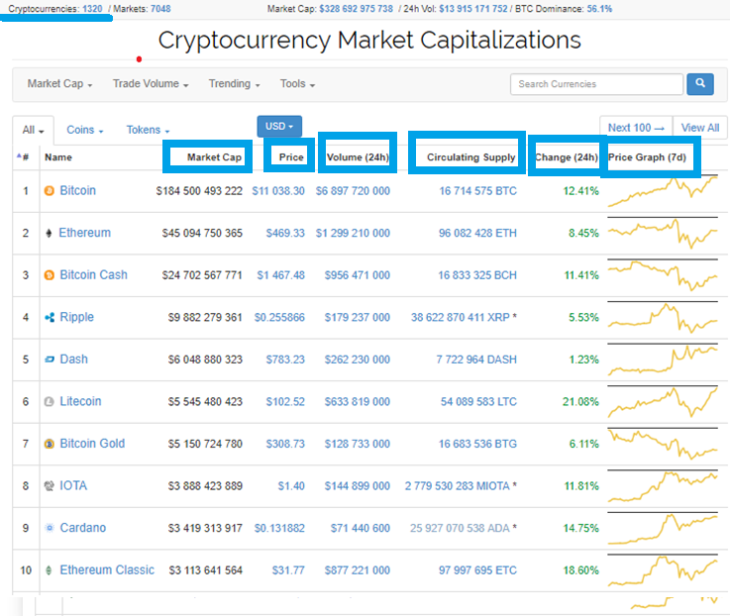

As we see the above left corner, by today (02/12/2017) there is **1320 cryptocurrencies**.

We can see the current **Market Cap** of all the **cryptocurrencies**, the volume for the past 24h.

The **Price** is calculated by dividing **Market Cap** to **Circulating Supply**.

Let’s choose one of the **cryptocurrencies** and see what they have.

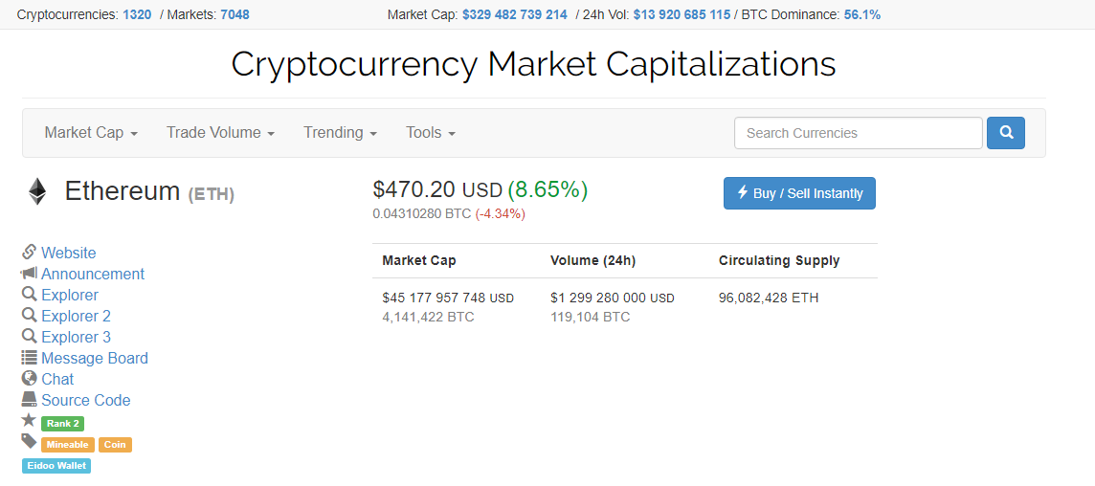

And this is how it looks like.

You can see the **Website**, you can read the **Source Code**, look at the **Price Chart** and so on.

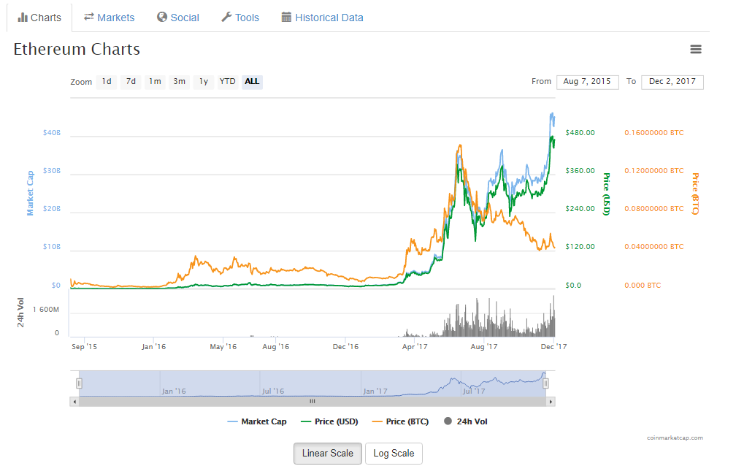

## Explore Ethereum Network Stats

Go to <https://ethstats.net/> and see the current **Ethereum Network Stats**

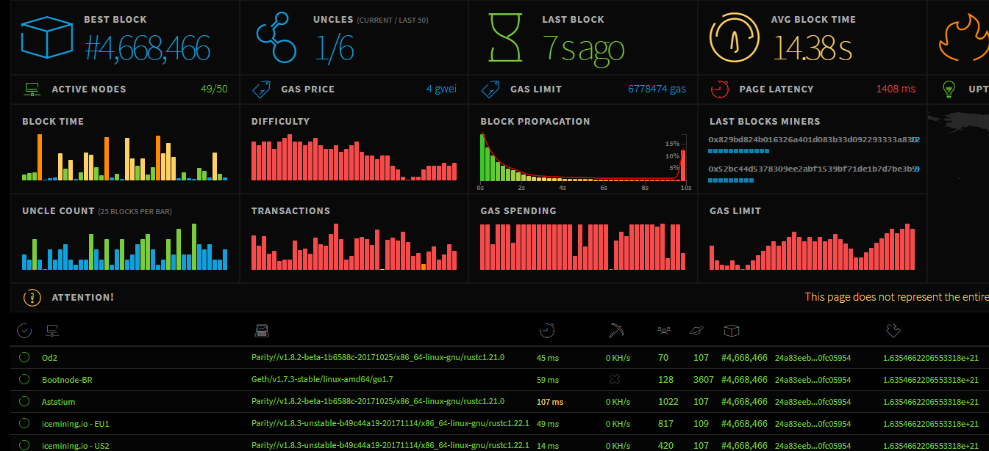

Here you can see the **Current Block** of the **Ethereum network**.

The **Gas Limit** which is 6 778 474 **Gas** at the moment (03.12.2017)

**Average Time** for **Block** creation.

We will cover all of this information in the next lectures.

## Explore Bitcoin Network Stats

Go to <https://blockchain.info> and see the current **Bitcoin Network Stats**

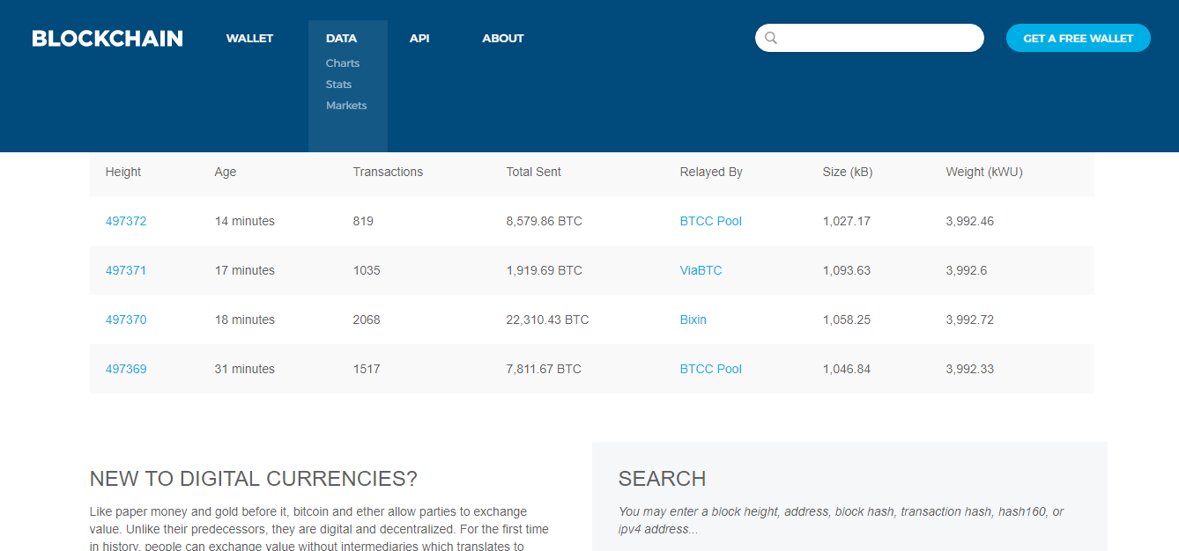

Here you can see the **Latest Blocks** of the **Bitcoin network**.

The **Network Activity** and **Mining Information**.

**Blocks Details** and **Currency stats** and so on.

We will cover all of this information in the next lectures.

## Compare Bitcoin and Ethereum with other cryptocurrencies

Search and Learn about the other **cryptocurrencies**. Explore them.

Choose **10 cryptocurrencies** and compare them with **Bitcoin** and **Ethereum**.

The criteria for comparing them are:

* Current Market Price (USD)
* Market Capitalization (USD)
* Is it minable
* Block Creation Time
* Current Block Number
* Consensus Protocol
* Hashing Algorithm
* Circulating supply

Fill the “**5. Compare-Bitcoin-and-Ethereum-with-Other-Cryptocurrencies.xlsx”** file.

# What to Submit?

Submit the “**5. Compare-Bitcoin-and-Ethereum-with-Other-Cryptocurrencies.xlsx”** file as **homework** with the name **“5. Compare-Bitcoin-and-Ethereum-with-Other-Cryptocurrencies-Your-Name.xlsx”** at the course Web site.